Course: High Performance Computing Lab

Practical No 1

PRN: 21510071
Name: Madhusudan Ramnivas Kabra
Batch: B3

Title: Introduction to OpenMP

Problem Statement 1 – Demonstrate Installation and Running of OpenMP code in C
Recommended Linux based System:
Following steps are for windows:
OpenMP – Open Multi-Processing is an API that supports multi-platform shared-memory multiprocessing programming in C, C++ and Fortran on multiple OS. OpenMP uses a portable, scalable model that gives programmers a simple and flexible interface for developing parallel applications for platforms ranging from the standard desktop computer to the supercomputer.

To set up OpenMP,
We need to first install C, C++ compiler if not already done. This is possible through the MinGW Installer.
Reference: Article on GCC and G++ installer (Link)
Note: Also install `mingw32-pthreads-w32` package.

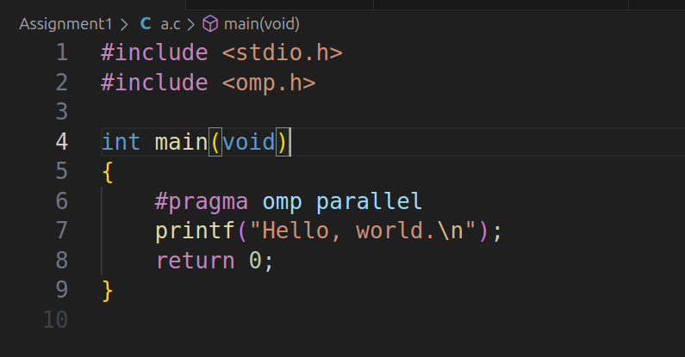
Then, to run a program in OpenMP, we have to pass a flag `-fopenmp`.
Example:
To run a basic Hello World,
gcc -fopenmp test.c -o hello
.\hello.exe
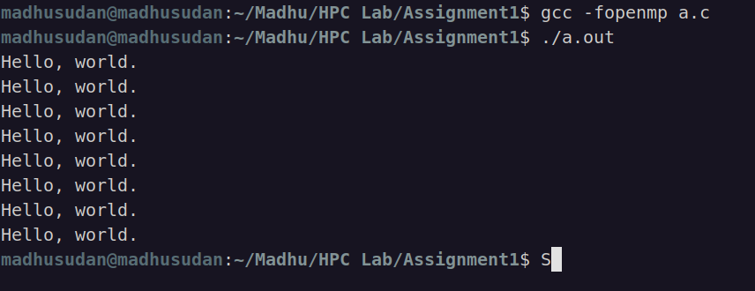

Problem Statement 2 – Print ‘Hello, World’ in Sequential and Parallel in OpenMP
We first ask the user for number of threads – OpenMP allows to set the threads at runtime. Then, we print the Hello, World in sequential – number of times of threads count and then run the code in parallel in each thread.

Code snapshot:
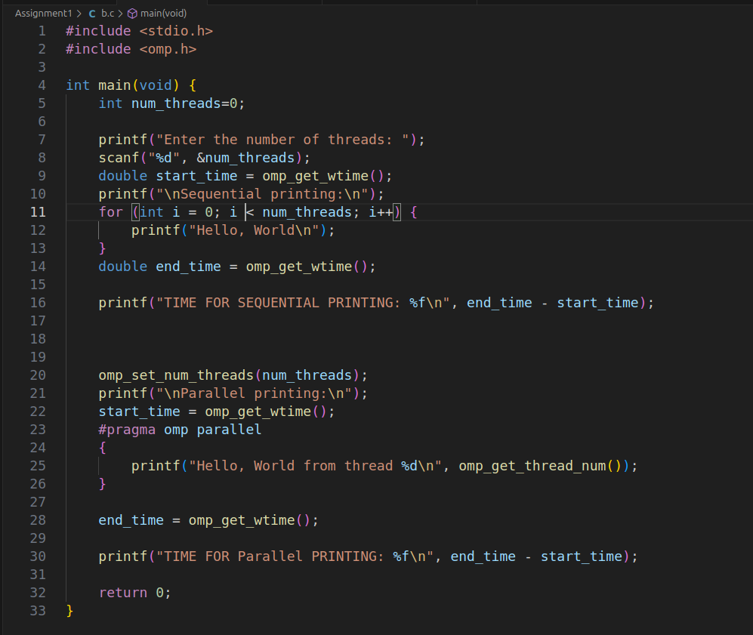
Output snapshot:
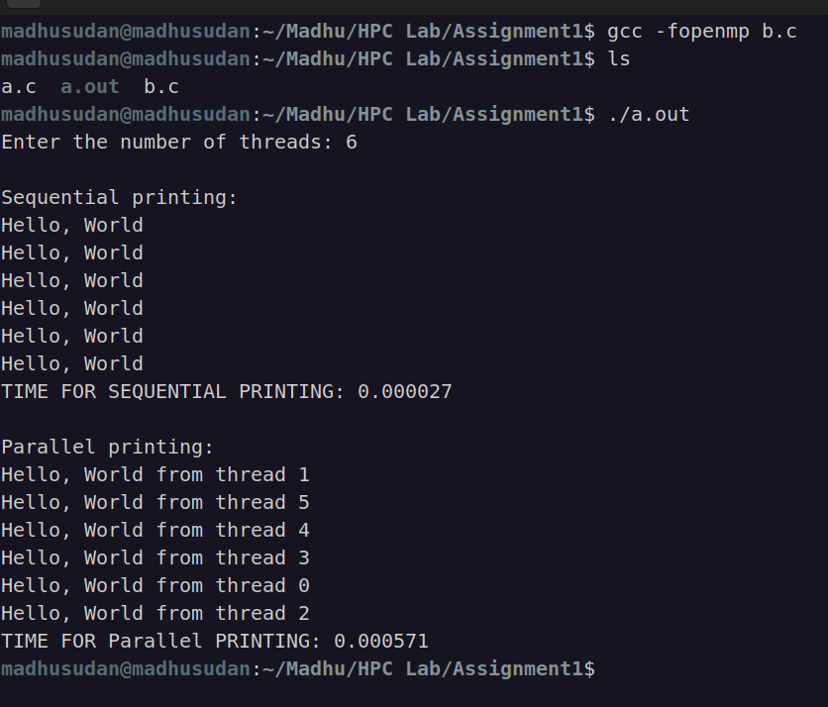

Assignments : https://github.com/MadhusudanKabra/HPC-Assignments

Problem statement 3: Calculate theoretical FLOPS of your system on which you are running the above codes.
cat /proc/cpuinfo
lscpu | grep “Mhz”
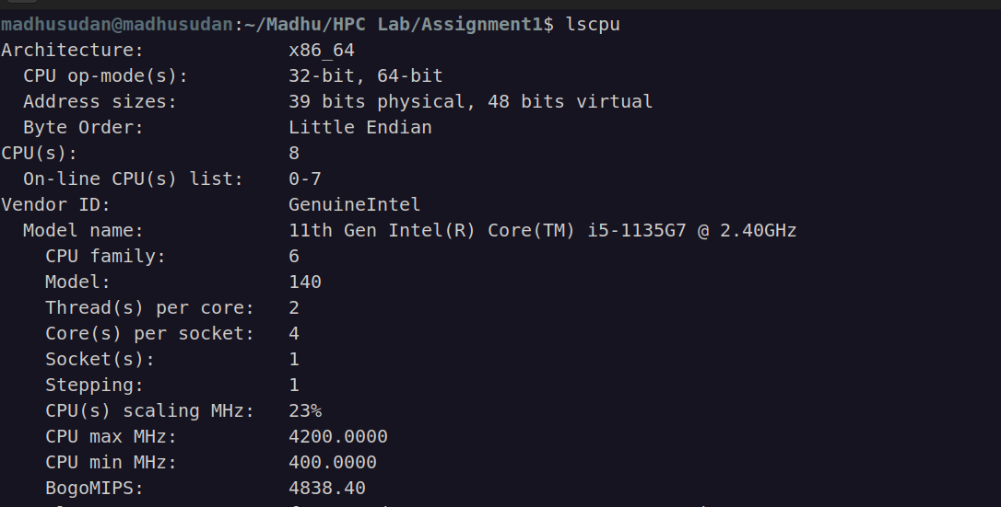

No of Flops: No of Core * ClockSpeed * IPC * 10**9
No of Core = 8
Clock Speed = 2.40 GHz
IPC = 16
ANS:= 307.20 GFLOPS

Assignments : https://github.com/MadhusudanKabra/HPC-Assignments

